M4L Life Lessons 11 How to Live Life to the Full: The Yin-Yang Principle
Life is a continuous series of problems and opportunities. The challenge confronting us is how to achieve our life goals by overcoming obstacles and making the best use of opportunities. This lesson focuses on the wisdom and skills needed to live fully regardless of the vicissitudes of life.
Living life to the fullest implies that we are able to develop our full potentials and become fully human. It does not mean packing our daily lives with happiness and exciting activities. Nor does it mean living a privileged life free from troubles and deprivation. However, it does mean that we become liberated from emotional bondages and crippling anxieties so that we can be free to pursue our ideals and complete our life mission.
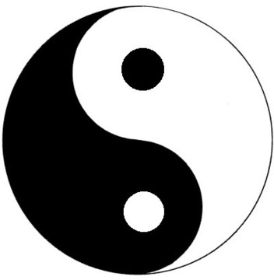Generally, people tend to make two mistakes: some want to focus solely on the positive and ignore the negative side of the human condition; others focus only on the negative and ignore what's good and beautiful about life. The Yin-Yang way avoids these two extremes.
As the symbol shows, life is a balancing act between positives and negatives. In fact, each positive experience contains the seed of self-destruction; each negative contains the seed of personal growth. The Yin-Yang approach avoids the excesses of the pursuit of happiness and success, while allowing us to discover the potential benefits of negative experiences.
The dual-systems model represents a psychologist's attempt to translate the Yin-Yang principle into psychological processes. Simply put, the dual-systems model focuses on the interaction between our approach and avoidance tendencies, in order to yield the best possible outcome.
The PURE model represents a meaning-centered approach to developing what is good and right about us. This model emphasizes the four pillars of meaningful living (purpose, understanding, responsibility, and enjoyment), because the pursuit of meaning is most likely to bring out goodness in ourselves and in others.
The ABCDE intervention represents a meaning-centered approach to transforming what is hindering or troubling us. It captures the power of acceptance, belief, commitment, discovery, and evaluation/enjoyment.
Basically, life involves a series of approach-avoidance conflicts. In every situation, there are always two options: go or no go. If you choose to go ahead with your plan, you can rely on the PURE principle to ensure that you are pursuing something that is meaningful and worthwhile. However, in the process of goal striving, there are always bumps in the road or real obstacles. These setbacks will make you consider the other option of “no go”; this thought will trigger the ABCDE process to evaluate how to overcome the difficulty.
The ABCDE process might result in continuation of your initial goal striving, believing that the problem is solvable. Alternatively, the ABCDE process might lead to the conclusion that the original goal is not attainable and it is better to give up and switch to an alternative goal, thus restarting the approach process.
The continuous interactions between approach and avoidance represent a constant tension between Yin and Yang. Optimal functioning is possible when we do not invest all our energy in futile pursuit of an unrealistic and unattainable goal. Similarly, we would not be living fully if we gave up readily and spent most of our days in avoidance mode.
The dual-systems model enables us to embrace all of life and benefit from both positive and negative experiences. This Yin-Yang way reflects the Buddhist ideal of compassion and letting go; it is also consistent with the Christian teaching of loving our neighbours and accepting the troubles in this world.
Since this Meetup falls on Thanksgiving Sunday, we would like to hear from members about how we can celebrate this occasion. Here is a link to a historical account of the first thanksgiving: http://youtu.be/YsdzjdT_LkY

