Marital Happiness as a Function of Age
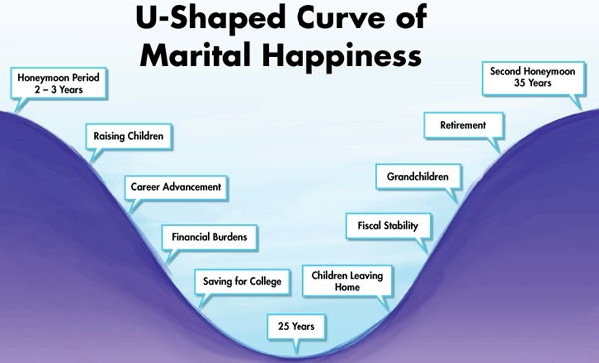

Sternberg’s (1986) Triangular Theory of Love
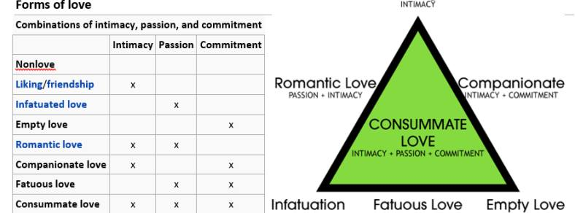

Lee’s (1973) Six Types of Love

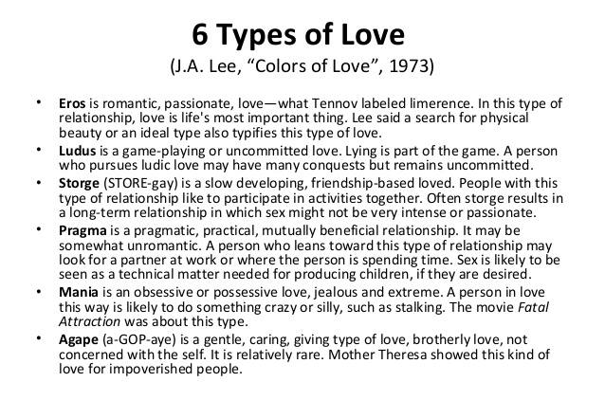

Wong’s (2011) Four Types of Happiness
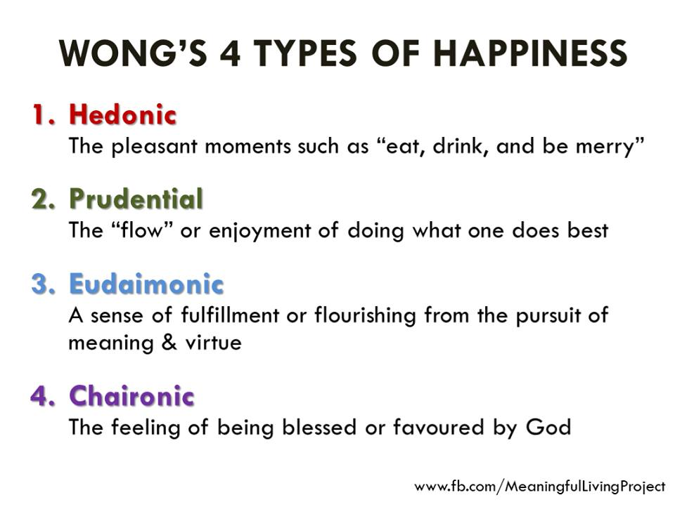

Ten Commandments for Couples
- Be a blessing, not a problem
- Be a support, not a hindrance
- Be willing to sacrifice for each other
- Bring each other happiness, not sadness
- Pursue common interests and common dreams
- Seek to understand more than to be understood
- Be quick to forgive and slow to get angry
- Be quick to listen and slow to respond
- Focus on the positive in communication
- Remember the good times not the bad times

Discussion Questions
- From your personal experience, which are the best or worst years of your married life? Do you know why?
- What kind of love best characterizes your present relationship? What would be the best way to improve your relationship?
- Have you experienced all four kinds of happiness in your marriage? In what ways can you enhance these different types of happiness in your current relationship?
- What aspects of the “Ten Commandments for Couples” are most helpful to you and why?

Rollins, B. C., & Feldman, H. (1970). Marital satisfaction over the family life cycle. Journal of Marriage and Family, 32(1), 20-28. doi:10.2307/349967
Sternberg, R. J. (1986). A triangular theory of love. Psychological Review, 93, 119-135. doi:10.1037/0033-295X.93.2.119
Lee, J. A. (1973). The colors of love: An exploration of the ways of loving. New York, NY: New Press.
Wong, P. T. P. (2011). Positive psychology 2.0: Towards a balanced interactive model of the good life. Canadian Psychology, 52(2), 69-81.

