Meetup 2017: What Makes for a Happy and Healthy Marriage?

Lesson 5: The Different Faces of Marital Happiness

May 21, 2017 | © Paul T. P. Wong
Do you still believe in the promise of living happily ever after? The answer hinges on your understanding of the complexity of marital relationships. This Meetup will explore three important variables that can impact marital satisfaction: length of marriage, type of love, and type of happiness.

Marital Happiness is a Function of the Length of Marriage
Most research shows that both life satisfaction and marital satisfaction are a “U” function of age, as shown in Figure 1.
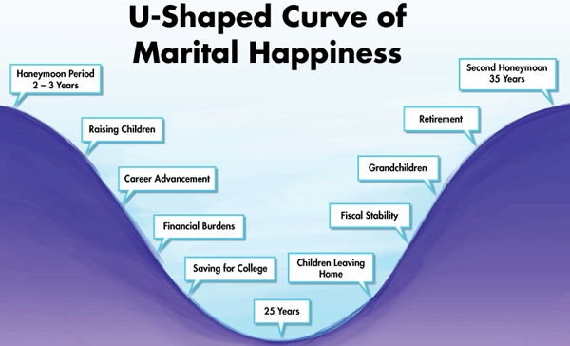
Figure 1. Marital happiness as a function of age (Rollins & Feldman, 1970).
It is quite intuitive that the stress of getting oneself established in a career and raising a family can negatively affect marital satisfaction. It is also understandable that after 25 years of marriage, people may go through a middle-age crisis or an unsettling period of life. The good news is that if you do not give up and do make the necessary adjustments, you will eventually experience an upswing in marital satisfaction.

2. Marital Happiness is Related to the Right Type of Love
According to Sternberg’s triangular theory of love, different types of love are made up of different combinations of the three basic components of love—intimacy, passion, and commitment—as shown in Figure 2.
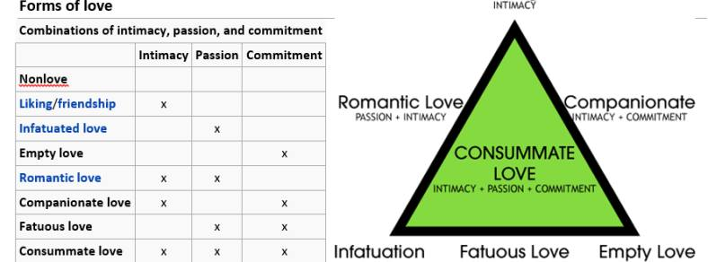
Figure 2. Sternberg’s (1986) triangular theory of love.
An ideal marriage should be a case of consummate love, consisting of all three components. However, in order to maintain consummate love over the entire course of marriage, romantic love needs to gradually morph into companionate love. When one is addicted to the emotional high of romantic love, one will likely go down the risky path of many costly breakups and heartbreaks, and one may eventually spend one’s old age alone. In contrast, when companionate love dominates the relationship, one will be blessed with the best gift in life—a lifelong friendship.
Another way to define different types of love can be found in Figure 3.
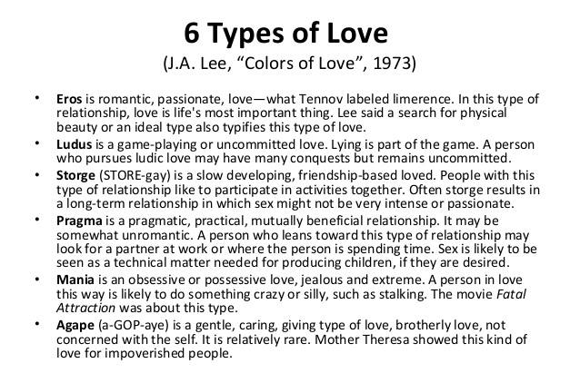
Figure 3. Six types of love according to Lee (1973).
While romantic love is characterized by eros, companionate love is characterized by storge (friendship), and agape (a caring type of love). Thus, companionate love is the main contributor to a healthy and happy marriage, especially in later years.

3. Marital Satisfaction is Related to the Right Type of Happiness
There are at least four types of happiness according to Wong (2011), as shown in Figure 4. We all need happiness in our marriage, but marital satisfaction depends on what type of happiness we pursue. Hedonic happiness is part of a happy marriage. Even older couples can still frequently enjoy a good “date” of dining out or going to a theatre or concert. However, when one’s life is completely devoted to hedonic pursuit, it will likely lead to boredom and risky exciting activities to combat that boredom.
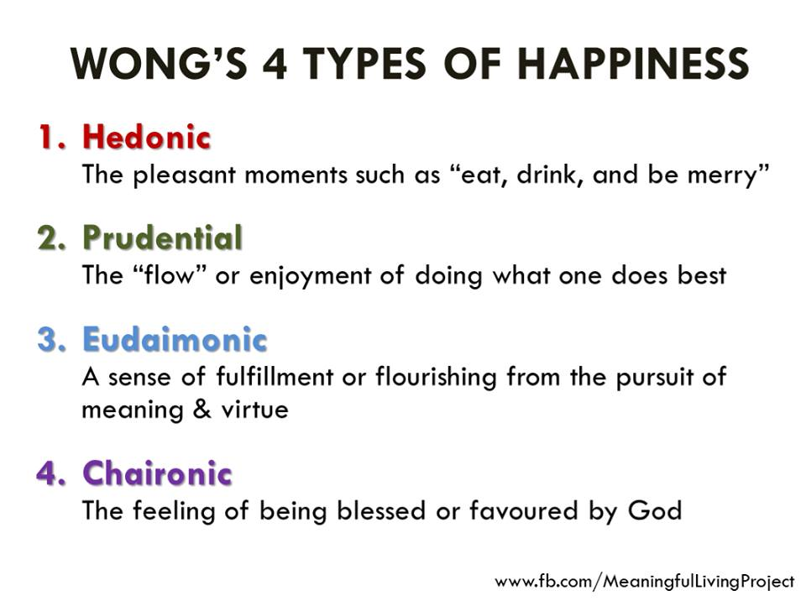
Figure 4. Four different types of happiness (Wong, 2011).
Prudential happiness refers to the feelings of satisfaction that come primarily from living a fully engaged life and doing what one loves and does well. Eudaimonic happiness is characterized as the pursuit of moral excellence, the big picture of human existence, or a life of meaning and purpose; it is related to living a virtuous life as a decent human being. Finally, chaironic happiness, a term that I coined, simply means receiving blessings or gifts of joy that are not dependent on our own effort and accomplishments. This kind of happiness can be experienced only when we are open and attuned to the transcendental reality or close to nature and appreciative of its beauty; it represents the spiritual pathway to happiness.
Ideally, a happy and healthy marriage consists of all four kinds of happiness, shared by both partners. In other words, the pursuit of happiness needs to be balanced and mutual. When husband and wife are on entirely different paths in their pursuit of happiness, they will eventually drift apart.

Ten Commandments for Couples
- Be a blessing, not a problem
- Be a support, not a hindrance
- Be willing to sacrifice for each other
- Bring each other happiness, not sadness
- Pursue common interests and common dreams
- Seek to understand more than to be understood
- Be quick to forgive and slow to get angry
- Be quick to listen and slow to respond
- Focus on the positive in communication
- Remember the good times not the bad times

Discussion Questions
- From your personal experience, which are the best or worst years of your married life? Do you know why?
- What kind of love best characterizes your present relationship? What would be the best way to improve your relationship?
- Have you experienced all four kinds of happiness in your marriage? In what ways can you enhance these different types of happiness in your current relationship?
- What aspects of the “Ten Commandments for Couples” are most helpful to you and why?

References
Lee, J. A. (1973). The colors of love: An exploration of the ways of loving. New York, NY: New Press.
Sternberg, R. J. (1986). A triangular theory of love. Psychological Review, 93, 119-135. doi:10.1037/0033-295X.93.2.119
Wong, P. T. P. (2011). Positive psychology 2.0: Towards a balanced interactive model of the good life. Canadian Psychology, 52(2), 69-81.

