Journey of Personal Development (Part 1) - Know Yourself
© Paul T. P. Wong
Who are you? What are you?
- What is the difference between “Who you are” and “What you are”?
- The former refers to your self-definition; the latter refers to your descriptive category
- How you answer these two questions shape how you live and how you relate to others
- How would you describe yourself in a few words?
- In what ways does your self-concept affect how you live and how you relate to others?
Why is self-knowledge emphasized in both Eastern and Western cultures?
- Our self-concept affects how we live and how we relate to others
- The problem with poor self-esteem
- The problem with high self-esteem
- The problem with overall self-evaluation
- The problem with an externally imposed self-concept
- Without self-knowledge, it is difficult to make positive change
The negative consequences of not knowing your real self:
- Choosing the wrong career or wrong mate
- Acting inappropriately and encountering unnecessary frustration.
- Wandering in the wilderness, feeling lost
- Going through life without living your own life
- Feeling uncomfortable in your own skin
- Experiencing mental health and relational problems
The positive consequences of knowing your real self:
- Assuming personal responsibility for your life
- Discovering your true or authentic self
- Creating your unique path and future
- Finding your passion and your mission
- Living a life of purpose, productivity, & happiness
Self-acceptance is a pre-condition for positive change
- Acceptance enables one to have an honest & realistic self-assessment
- Accept the urgent need for change in certain areas of life
- Accept one’s inner pain as a warning sign for the need to change
- Acceptance of the paradoxical nature of human existence enables one to manage better
Self-acceptance is a pre-condition for a healthy self-concept
- Accept one inherent value and worth as a human being
- Accept one’s capability to make positive changes and grow
- Accept one’s capability to choose and pursue what really matters
- Accept one’s capability to make a unique contribution
- Accept one’s spiritual nature and capability to live a virtuous and ethical life

The How of Finding Yourself
Exploring the four worlds you inhabit:
- Your spiritual world – your religiosity/spirituality, ultimate concerns & core moral values
- Your personal world – your present & past, your strengths & weaknesses, your emotions & thoughts
- Your social world – your family, friends, associations, & cultural context
- Your physical world – your physical characteristics and the natural and concrete surroundings
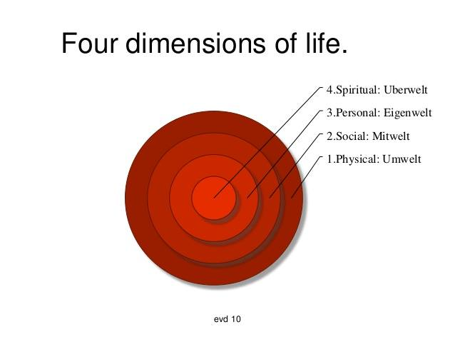
How to develop a positive self-concept
- Belief in one’s inherent value and worth
- Belief in one’s capacity for growth
- Making constant self-improvement
- Embracing both strengths and weaknesses
- Exercising one’s freedom and responsibility to pursue what really matters
- Engaging in relationships that matter

How to identify hindrances to self-knowledge:
- Defensive mechanisms
- Blind spot
- Pride & inflated ego
- Lack of self-confidence
- Lack of self-reflection
- Lack of self-acceptance
- Escape from the past

Your real self is an evolving system of meaning related to:-
- Your unique talents, dark side, and temperament
- Your unique root from your family, race, and culture
- Your unique calling based on your core values, beliefs, and worldviews
- Your physical strengths and limitations
- Your inner voice without the external noises
- Different dimensions of you in different stages of development
Tools to know yourself:
- Self-reflection and self-evaluation
- Mindful meditation
- Keep a journal & write out your life story
- Ask people who know you best to tell you about yourself
What constitutes a healthy self-concept?
- A realistic and honest assessment of different aspects or dimensions of self
- Accepting and embracing yourself as you are – both your potential and limitations
- The capacity to take responsibility for your choices and actions
- The capacity to love and take care of yourself with self-compassion
- The capacity to change and develop your best self
- The capacity to pursue what really matters to you
- A flexible and holistic self-concept that is functional and adaptive
- Based more on experience and understanding than emotions

Take Home Message
- Knowing yourself is the best investment you will ever make
- Your biggest challenge is to discover your gift and give it away
- Start doing one thing that is consistent with your most cherished value

Lesson 1: Self-Discovery
© Paul T. P. Wong
Open-Ended Questions for Reflection and Group Discussion

- How would you answer the question: “Who am I?”

- How would you answer the question: “What kind of person do I want to become?”

- What was your worst or most painful memory from childhood?

- What was your best or happiest memory from childhood?

- If money were not an issue, what would you want to do with your life?

- Is there anything that you have always felt excited and passionate about pursuing?

- What would be the mission statement or motto for your life?

- What are you going to work on over the next few days to help you feel more comfortable being yourself?

